

Assessment Information/Brief 2025-26

Module title | Automation and Robotics (BEng Control and Automation)
CRN | 50295
Level | 6
Assessment title | Design of a Robot Workcell for a Coating Task
Weighting within module | This assessment is worth 50% of the overall module mark.
Submission deadline date and time | Friday 12th December 2025 by 16:00  Any submission received after 16:00 (even if only by a few seconds will be considered as late).  Students with a Reasonable Adjustment Plan (RAP) should check their RAP to see if an extension to this submission date has been agreed.
Module Leader/Assessment set by | Dr Saber Mahboubi  (email: s.mahboubiheydarabad@salford.ac.uk)
How to submit | You should submit your assessment via Turnitin on the Blackboard Module page under the Assessments menu item. There is a submission area for the report there
Assessment task details and instructions | You are required to design a robot manipulator that will operate within a workcell to transfer parts through a coating and curing process and deliver them to an output conveyor.  Using the knowledge gained from this module and through analytical analysis, you must select appropriate joints and linkages for the manipulator to move the workpiece, keeping the design as simple as possible. This is a generic design and does not require you to specify parts from a specific vendor.  You must calculate suitable forward/reverse kinematic solutions for the joints and linkages to place the work piece at the required task positions.  You must specify suitable sensors for the manipulator to allow suitable control of the collection and the position of the work piece as required.  A detailed brief is given at the end of this document.  The deliverables required from this assessment are:  Design Report (Due 12th December, 2025 by 16:00)  This design report must detail the design of your manipulator arm and sensor suite. You should justify your reasoning for your particular design approach through research you have undertaken. You should provide suitable diagrams and calculations as required by the tasks above that will prove the operation of the robot manipulator meets the design requirement.  You do not need to provide large amounts of background material on robots or sensors other than that needed to justify your design approach. There is no requirement to provide extended numerical calculations, simply state the algebraic form of equations you are using, the numerical values being used for each equation variable and the final result. You must reference all research sources that you use in all reports. This report is expected to be around 3000 words in length.
Knowledge and Understanding  Practical, Professional or Subject Specific Skills | Assessed intended learning outcomes  On successful completion of this assessment, you will be able to:  - Design of a robot manipulator from task specification  - Knowledge of sensor types and operation  - Ability to apply forward kinematic calculations  - Develop a solution for a given design specification.  - Demonstrate analytical skills in designing a robotic solution for an industrial problem.  - Communication: Presenting Information in the form of clear written reports  - Design skills: Demonstrating your ability to produce a design from a specification
Employability Skills developed / demonstrated | Communication NO  Critical Thinking and Problem Solving YES  Data Literacy YES  Digital Literacy YES  Industry Awareness YES  Innovation and Creativity YES  Proactive Leadership NO  Reflection and Life-Long Learning YES  Self-management and Organisation YES  Team Working NO
Module Aims | Module Aims  To provide the student with an understanding of control theory and robotic systems that can be applied to industrial automation situations.
AI tools cannot be used | For this assessment the use of tools, software, or features of software which use artificial intelligence to generate content such as text, images or data, is not authorised. The work you submit must be entirely your own, representing your own abilities and ideas. Use of AI to generate a response to questions in this assessment, or the assessment brief, is academic misconduct. Reliance upon AI tools will also become problematic for you both in further study and your future career as the knowledge, critical and analytical thinking required for this assessment are essential, foundational skills you are expected to acquire and develop independently.
Word count | The report is expected to be written as a design report. It should be around 3000 words in length and have appropriate introductions and conclusions. Fully labelled diagrams are expected. Harvard 7 referencing is expected for all referenced material. There is no penalty for exceeding the word count up to 50%.
Feedback arrangements | You can expect to receive feedback by Tuesday 20th January 2026. This will take the form of annotated comments and a mark breakdown returned to you via Turnitin/Blackboard.
Academic Integrity and Referencing | Students are expected to learn and demonstrate skills associated with good academic conduct (academic integrity). Good academic conduct includes the use of clear and correct referencing of source materials. Here is a link to where you can find out more about the skills which students need:  Academic integrity & referencing  Referencing  Academic Misconduct is an action which may give you an unfair advantage in your academic work. This includes plagiarism, asking someone else to write your assessment for you or taking notes into an exam. The University takes all forms of academic misconduct seriously.
Assessment Information and Support | Support for this Assessment  You can obtain support for this assessment from the module leader who will be available via email.  email: s.mahboubiheydarabad@salford.ac.uk  You can find more information about understanding your assessment brief and assessment tips for success here.  Assessment Rules and Processes  You can find information about assessment rules and processes in the Assessment Support module in Blackboard.  Develop your Academic and Digital Skills  Find resources to help you develop your skills here.  Concerns about Studies or Progress  If you have any concerns about your studies, contact your Academic Progress Review Tutor/Personal Tutor or your Student Progression Administrator (SPA).  askUS Services  The University offers a range of support services for students through askUS including Disability and Inclusion Service, Wellbeing and Counselling Services.  Personal Mitigating Circumstances (PMCs)  If personal mitigating circumstances (e.g. illness or other personal circumstances) may have affected your ability to complete this assessment, you can find more information about the Personal Mitigating Circumstances Procedure here. Independent advice is available from the Students’ Union Advice Centre about this process: https://www.salfordstudents.com/advice/centre
Assessment Criteria | The assignment is marked out of 100.  The marks are assigned to the various elements of the design in the proportions given below:  - Design of a robot manipulator with appropriate joints, linkages, and end effectors to undertake task (30%)  - Calculation of required joint angles for each task location (40%)  - Selection of suitable sensors to ensure tasks can be undertaken with required precision (30%)
In Year Retrieval Scheme | Your assessment is not eligible for in year retrieval.
Reassessment | If you fail your assessment, and are eligible for reassessment, you will need to resubmit your work. The re-submission date will be in July with the exact date confirmed in a Blackboard announcement  The reassessment comprises the same assignment specification, but reassessments grades are capped at 40%.

Design of a Robot Workcell for a Coating Task
Brief
You are required to specify a robot manipulator that can take incoming plastic components and put them through a conductive Nickle based paint spray and curing process within a workcell. The workcell is laid out as below:
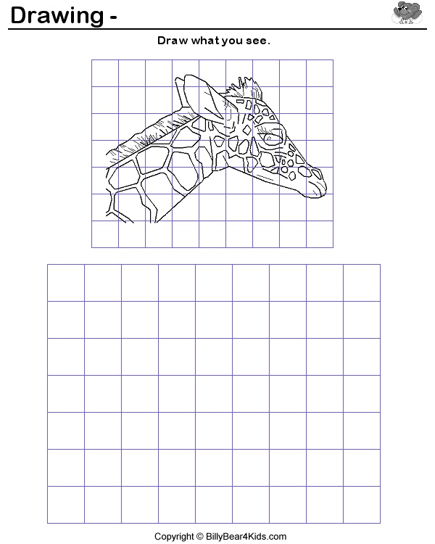

Output
Conveyor
X
X
B
A
Coating
And
Curing
Unit
X
X
Input
Conveyor
GRID SIZE: 0.5m Squares
Part

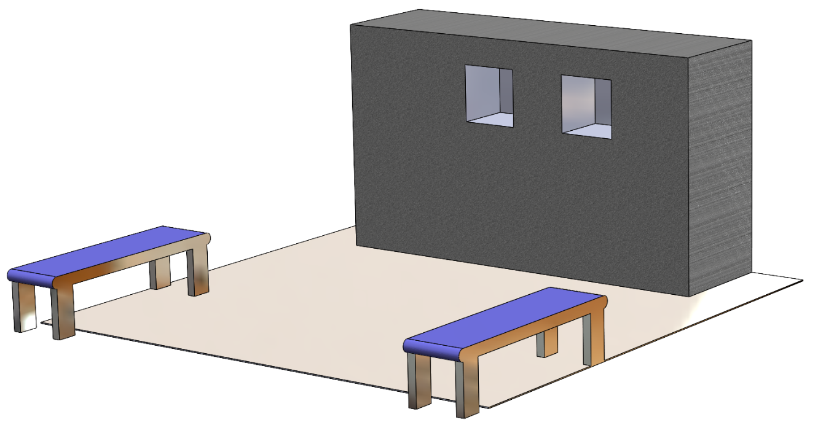

The apertures are in the side of the curing unit are both 0.5m² square centred at 1.5m from the floor. The apertures are covered with a flexible curtain that can be pushed aside as the part is inserted from the side. To avoid clipping the edges of the aperture the part should be inserted horizontally and perpendicular to the front face of the aperture.

The process required is as follows

- The part needs to be collected from the input conveyor where it will stop at the point marked X.

- The part needs to be moved to aperture A in the coating unit at the point marked X. Here it needs to be rotated through 360 degrees whilst the Nickle based coating is applied

- Once the coating is applied, the part needs to be moved to the UV curing unit at aperture B. Again it needs to be held at position X and rotated through 360 degrees whilst exposed to UV light

- Once cured the part needs to be deposited on the output conveyor at the point marked X

Additional information:

- Both conveyors are set so the base of the part arrives 0.5m above ground level
- Both apertures in the coating unit are centred at a height of 1.5m
- The part has a flat handling plate built into it that can be snapped off later. You must handle the plate using this plate to avoid obscuring areas that need to be coated.
- The part will arrive on the input conveyor with the handling plate facing up but can arrive at any orientation in that plane. Hence you will need to assess the orientation of this plate and allow suitable flexibility in your end effector to orient itself to grip this plate.

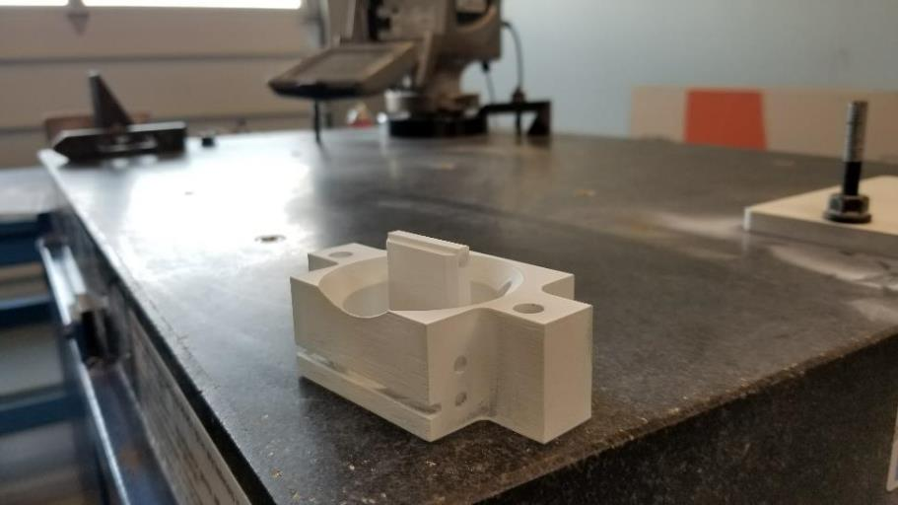

- The part has a mass of 500g and will fit through the coating unit apertures in any orientation as long as the base is presented perpendicular to the aperture front.

Your Tasks

You need to undertake the following tasks for this assignment.

- Design a suitable manipulator arm by specifying the link, joint types and end effectors to undertake the manipulation task. You should try to think the problem through so that the arm uses as few linkages as possible and uses the simplest joints possible (i.e. limited degrees of freedom). The manipulator must operate from a fixed point on the floor. Tracks are not allowed as this adds unnecessary complication. This is a generic design and does not require you to specify parts from a specific vendor. Make sure you justify your choices.

- Create a kinematic solution to specify the joint angles and link length (plus variability if extensible joints are used) to ensure the part can be placed at each of the 4 positions marked X. (4 kinematic calculations are required). No calculations are required for weight assessment but you should review your design to ensure there are no long links where carrying the mass of the part may cause a problem.

- Specify suitable sensors on the joints, links and end effectors that will allow the task to be undertaken. This should include the ability to assess part orientation. Do not over specify the sensors but ensure that the accuracy of the sensors you choose will not cause problems. Confirm this with suitable calculations.

Work Expectation

This assignment forms 50% of your possible marks for a 20-credit module. You would be expected to spend about 50 hours of time on it. Much of this will be in the design and calculations but a significant amount of time should also be spent on the written work. Hence there is an expectation for a detailed considered design and well written reports with appropriate diagrams of a high standard. All the submission (diagrams and text) must be in electronic format and submitted through the Turnitin system accessible within Blackboard.

Assessment Criteria and Marking Scheme
Mark range | 90-100 | 80-89 | 70-79 | 60-69 | 50-59
Overall level | Outstanding | Excellent | Very good | Good | Fair
Design of a robot manipulator with appropriate joints, linkages, and end effectors to undertake task (30%)
Scope | Outstanding design: Ideal choice of every component of the manipulator with a full justification for each in terms of the task requirement and demonstration of considering issues beyond the brief | Excellent design: Ideal choice of every component of the manipulator with a full justification for each in terms of the task requirements | Very good design. Ideal choice of every component of the manipulator with some justification for each in terms of the task requirements | Good design. . Good choice of every component of the manipulator with some justification for each in terms of the task requirements | Fair design. Workable choice of every component of the manipulator with justification for most of these in terms of the task requirements.
Calculation of required joint angles for each task location (40%)
Scope | Fully worked through solution for each position with all required variables specified. | Fully worked through solution for each position with almost all required variables specified. | Fully worked through solution for each position with all important variables specified. | Worked through solution for each position with serious error in one of the position calculations. | Worked through solution for each position with serious error in multiple position calculations.
Selection of suitable sensors to ensure tasks can be undertaken with required precision (30%)
Scope | Outstanding selection: Ideal sensors chosen and justified for all parts of the manipulator to provide all required feedback to complete the tasks and detect fault conditions. | Excellent selection: Suitable sensors chosen and justified for all parts of the manipulator to provide all required feedback to complete the tasks and detect fault conditions. | Very good selection: Suitable sensors chosen and justified for most parts of the manipulator to provide all required feedback to complete the tasks. | Good selection: Suitable sensors chosen, with some justification, for most parts of the manipulator to provide all required feedback to complete the tasks. | Fair selection: Suitable sensors chosen for most parts of the manipulator but one or two areas missing some required feedback. Some justification
Mark range | 40-49 | 30-39 | 20-29 | 10-19 | 0-9
Overall level | Adequate | Unsatisfactory | Poor | Very poor | Extremely poor
Design of a robot manipulator with appropriate joints, linkages, and end effectors to undertake task (30%)
Scope | Adequate design: Non ideal but workable choice of components of the manipulator with little justification in most cases. | Unsatisfactory design: One or more components could not actually perform the task required | Poor design: components could not actually perform the task required | Very poor design. Completely unsuitable components chosen | Extremely poor design. No real evidence at an attempt on the design
Calculation of required joint angles for each task location (40%)
Scope | Worked through solution for each position with serious error in all position calculations. | Some attempt at calculations. |  | No meaningful attempt at calculations.
Selection of suitable sensors to ensure tasks can be undertaken with required precision (30%)
Scope | Adequate Selection: Sensor suite would perform almost as required but selections are inappropriate and little justification has been given. | Unsatisfactory Selection: Some sensors are not fit for purpose and no justification has been given for their choice. | Poor Selection: Most sensors are not fit for purpose and no justification has been given for their choice | Very Poor Selection: No sensors chosen for some elements and rest are not fit for purpose and no justification has been given for their choice. | Extremely Poor Selection: No effort at a suitable choice of sensors demonstrated.

